**DRIVER DROWSINESS DETECTION**

**Abstract:**

This research paper is the review about my project “Driver Drowsiness Detection”. The idea behind this project is the accidents that are happing because of drivers sleeping while driving. In my report I have conducted complete study about how to resolve this issue so that we can put an end these kinds of problems. I have developed good solutions for these kind of problems by developing my project which gives the real idea how system works and changes can be made to improve the quality of the system.

**Introduction:**

Humans are tending make mistakes and we will recover from that mistake eventually with time. We develop the things that are not possible at some time like for travel we invented planes, cars, trains, metro, even electric vehicles now a days. Humans also affected by these technologies. Like if we want to travel for different country we can go within the certain time, but if compare to past it would have been dream come true. On that time only rich people can travel that far but nowadays everyone has their own vehicle for travelling purpose.

However, there are some rules to be followed for those who drives even for rich as well as poor. Everyone must obey the rules, neglecting our duties towards safer travel we end in tragedies. On road automobiles hold most power. In irresponsible hands .it can be destructive and sometimes, that carelessness is not acceptable when we are too tired to drive. In Order to monitor and alert a destructive outcome from such negligence.

Many researchers have written research papers on driver drowsiness detection but at times, some of the observations may be not accurate enough. Hence, to provide data and my perspective on the problem at hand, in order to improve their implementations and to further optimize the solution, this project has been done.

**2 LITRATURE SURVEY**

The survey which is done includes the present technologies and research available related to the topic of our project. It is an attempt to better understand the efforts that have gone into this field of study, an also understand where our efforts should be focused. This literature review has carried out on the topic of the current drowsiness detection technologies for facial landmarks detection [1], blink detection. Across many techniques to carry out drowsiness detection, which include deep CNN [2].

The developed system is the real time system. It uses image processing for eye detection.68 landmarks dataset used as classifier for eye detection. An algorithm to track object’s is used to track the eyes continuously. In order to identify the drowsy state of the driver we used Euclidian distance based on that we calculate the ratio. Using ratio we calculate the distance, based on distance we decide either the driver is sleep or not. The paper focus on developing a non-intrusive system which can detect fatigue and issues a warning on time. Research has been done on EAR based technologies for blink detection. The eye aspect ratio was used to detect if the eyes are closed or open.

The limitations of the paper are the normal camera was used which was not good enough in night. A night-vision camera should have been used. In some paper there some smart features are there which is not up to developer because he doesn’t know which features are used by driver.

In other paper there is driver monitoring system which monitors the driver. It detects drowsiness of driver along with different kinds of signals from other vehicle-based sensors. But, while deafferenting between moderate and severe levels, the model was not efficient enough.

**3.OBJECTIVES**

The main aim is to develop a system that is accurate to detect a driver’s drowsiness based on eyelid movement is reliable to give appropriate alerts as well as messaging emergency contacts through web. The other objectives designing a system that detects drowsiness of drivers by monitoring the eyes of the driver regularly, especially retina. The system should give an alert to the driver when driver going to sleepy stage.

**4. METHODLOGY**

Firstly, the face is localized in the image using facial landmark detection. Then, shape prediction methods are used to detect important features on the face. Face detection is done by OpenCV. In the next step, to estimate the location of 68 landmarks dataset that map to facial structure, a facial landmark detector which is included in dlib library. The EAR is computed using the ratio of distance between the horizontal and vertical eye landmarks for drowsiness detection. An alarm system is used for giving appropriate voice alerts when driver is feeling drowsy.

**5 SOFTWARE REQUIREMENT SPECIFICATION**

The proposed system must be able to detect the drowsiness given a proper real-time driving environment. The performance will depend on the quality of the camera. The proposed system must be well designed and easy to use in day and night as well. The system must able for use whenever it is required for the driver and it must meet the specified requirements. The system must able to recover whenever it gets crashed due to failure and become ready to use after recovery.

**System Requirements:**

Python: Python 3.6 and higher version

Libraries:

SciPy: It provides more utility functions for optimization, stats and signal processing. We used this to calculate the distance between eyelids.

Imutils: This package includes OpenCV+ convenience functions that perform basic tasks such as translation, rotation, resizing.

Dlib: It’s a package with C++ toolkit containing machine learning algorithms and tools to solve real world problems. We used this to find frontal human face and estimate it’s pose using 68 face landmarks.

Twilio: It’s a library for sending messages through web. It’s third party where we use api keys to do the messaging process.

**6. SYSTEM DESIGN**

**System Architecture:**

After passing our video feed to the dlib frame by frame, we are able to detect left eye and right eye feature of the face. Now we drew contours around it using OpenCV. Using SciPy’s Euclidean function, we calculated sum of both eyes aspect ratio which is the sum of 2 distinct vertical distance between the eyelids divided by its horizontal distance

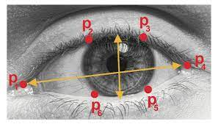

Now using aspect ratio, we calculate frame check value through which we decide either driver is sleep or not. We decide based frame check with its value 30 as minimum if its greater then minimum distance it’ll trigger an alarm as we as start to send messages such as text message, WhatsApp message and also email.

**Detailed Design:**

The system has been designed such that the face and eyes of the driver are always monitored and if the predefined levels of alertness are observed to be defaulted and compromised, then an appropriate alarm is set with messages and email, and accordingly action is taken to prevent any fatalities. The camera is set at top of the vehicle towards opposite to the face of the driver, for continuously monitor the driver. Upon the detection of drowsiness or sleep, the system in vehicle generates alert with additional procedures to warn the driver.

**7. EXPERIMENTAL RESULTS**

Result 1: Face Is Properly aligned and we can see green mark around the eyes.

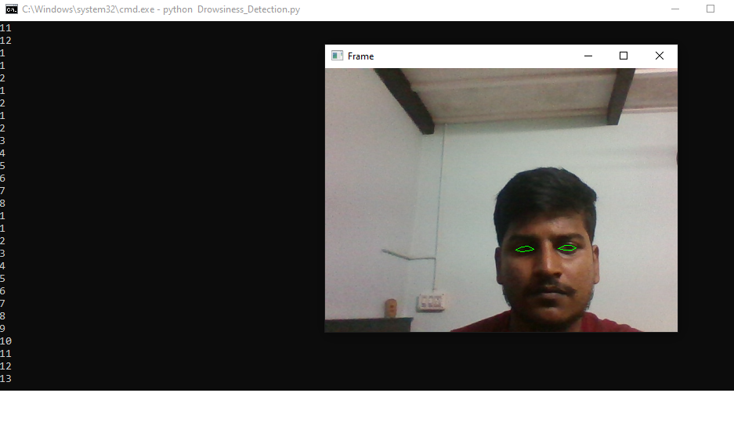

Result 2: In this on we can see the driver feeling bit sleepy

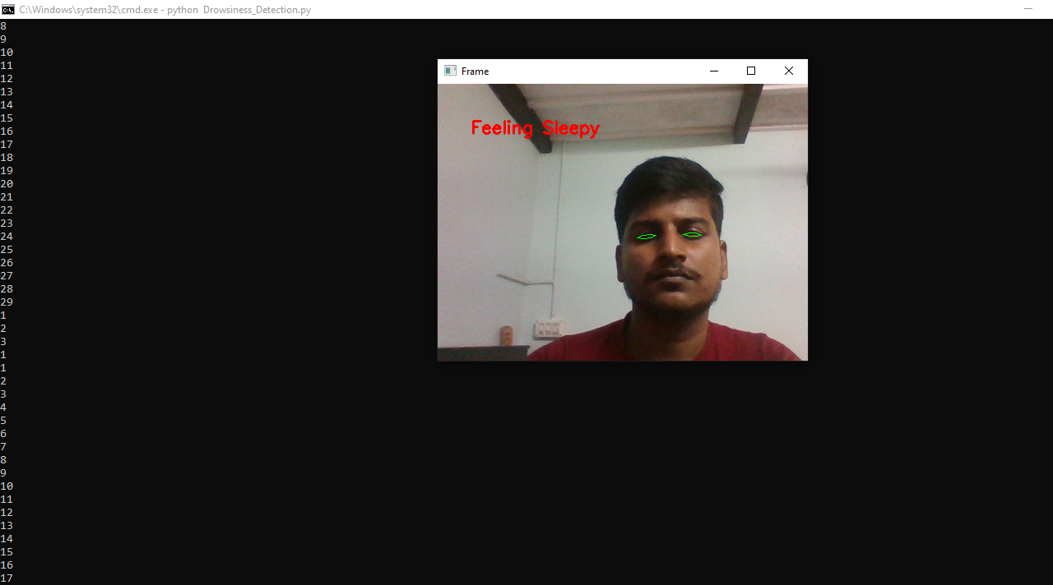

Result 3: Showing the driver is completely sleep and alert message.

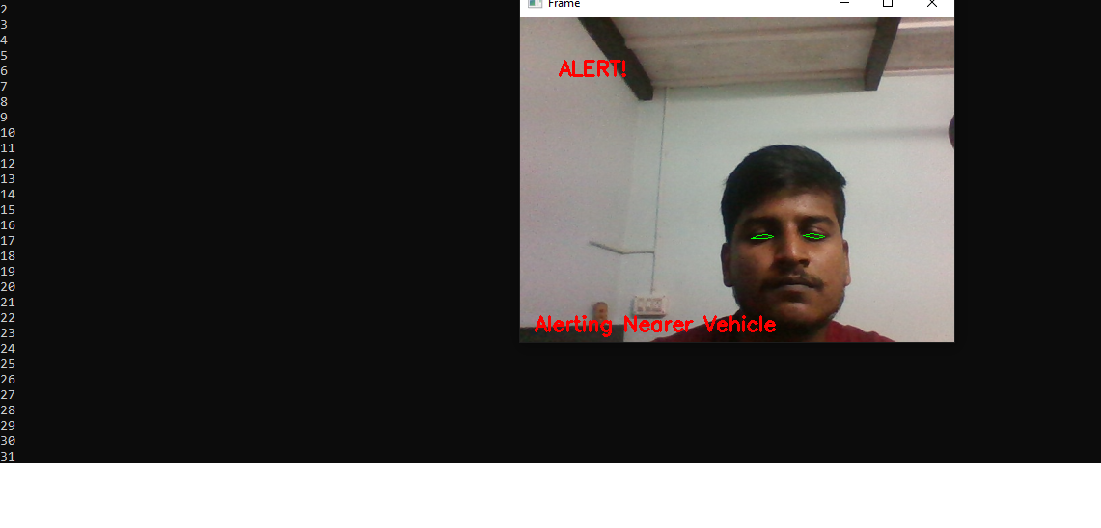

Result: Messages that are triggered due to sleepiness of driver

Text Message

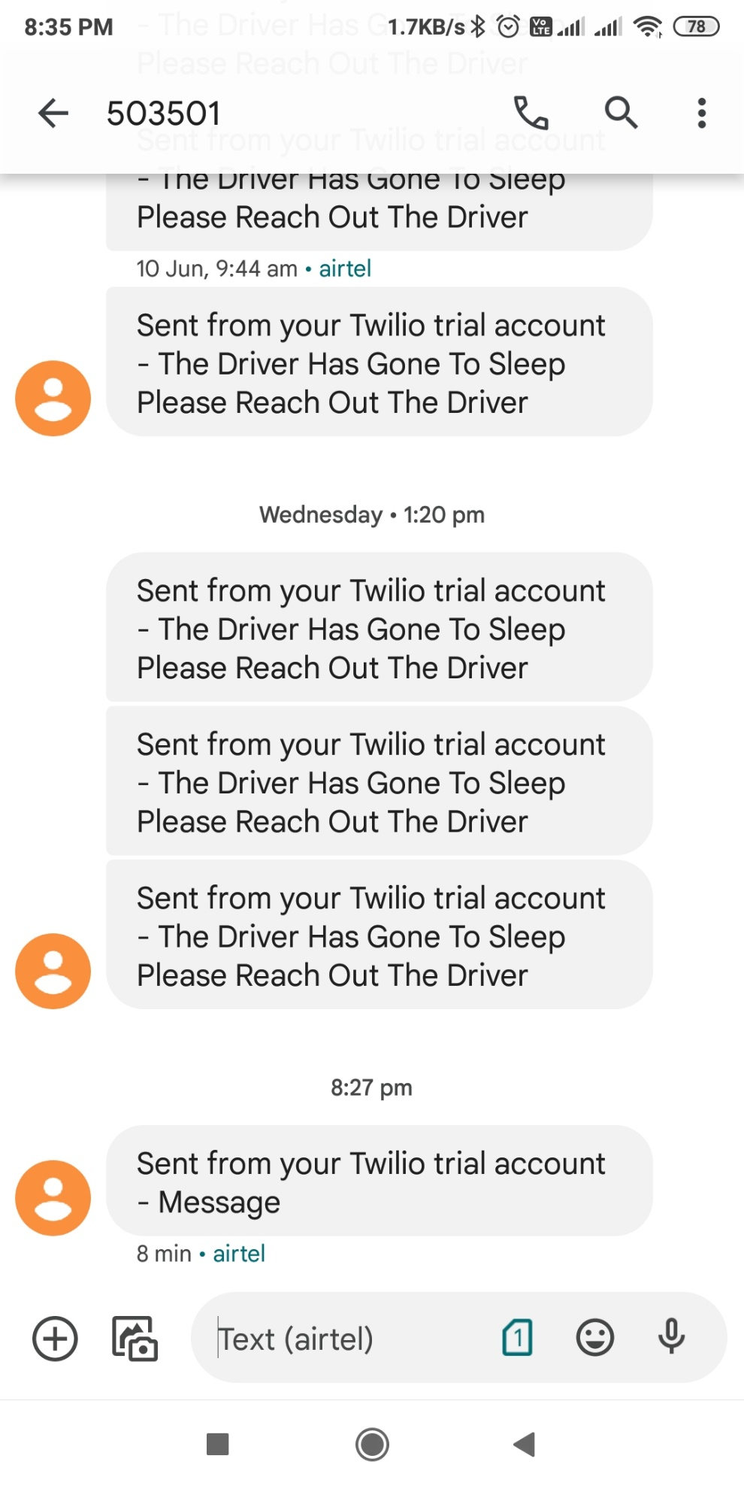

WhatsApp Message



Email Message



Performance Analysis

|  |  |
| --- | --- |
| I/P | DROWSINESS DETECTION |
| Result 1 | Not detected |
| Result 2 | Feeling Sleepy Stage |
| Result 3 | Completely in Sleep |

**8. CONCLUSION AND FUTURE SCOPE**

The developed model capable of detecting drowsiness by monitoring the eyes.68landmarks are used to detect import features on the face. The inputs are given to these methods are facial landmarks which are obtained from facial landmark detection. This module deals with EAR function which computes the ratio of distances between horizontal and vertical eye landmarks. An alert module is also deployed with messaging features as well. The whole project is designed to decrease the accidents and contribute to the technology with the goal to prevent fatalities caused due to road accidents. The future work of this paper can be focused on the use of outer factors for measuring fatigue and drowsiness. The outer factors may be weather conditions state of the vehicle, time of sleeping and, mechanical data. One of the important steps of preventive measures that are needed to be solve the problem is by continuously observing the driver state and giving information about their state to the driver so that they can take necessary action. In the future more work can be done to automate the zoom on the eyes after they are localized.

**LIMITATIONS**

The accuracy of the model degrades if the frames are not captured clearly due to any kind of obstacles such as goggles or sunglass. Camera operations such as auto adjustment with respect to zoom and rotation are not considered in conducting experiments. Once the eyes are localized, zooming in automatically will help increases accuracy. It is not possible to detect the eyes if they are not facing to the camera.

**REFERNCES**

[1] "EEG-based drowsiness detection for safe driving using chaotic features and statistical tests," Z. Mardi, S. N. Ashtiani, and M. Mikaili, Journal of Medical Signals and Sensors, vol. 1, pp. 130–137, 2011.

[2] "Squeezenet: Alexnet-level accuracy with 50x fewer parameters and 0.5Mb model size," F. N. Iandola, S. Han, M. W. Moskewicz, K. Ashraf, W. J. Dally, and K. Keutzer, Proceedings of the International Conference of Learning Representations, pp. 1-13, 2017.

[3] BOOK- COMPUTATIONALLY EFFICIENT FACE DETECTION; B. SCHLKOPF-A. BLAKE, S. ROMDHANI, AND P. TORR.

[4] BOOK- JAIN, “FACE DETECTION IN COLOR IMAGES; R. L. HSU, M. ABDEL-MOTTALEB, AND A. K. JAIN.

[5] BOOK- OPEN/CLOSED EYE ANALYSIS FOR DROWSINESS DETECTION; P.R. TABRIZI AND R. A. ZOROOFI

[6] PAPER -DRIVER DROWSINESS DETECTION SYSTEMS AND SOLUTIONS; ALEKSANDAR ČOLIĆ, OGE MARQUES, BORKO FURHT

# [7] PAPER -DRIVER DROWSINESS DETECTION USING ANN IMAGE PROCESSING; T. Vesselenyi, S. Moca, A. Rus, T. Mitra and B. Tătaru 2017